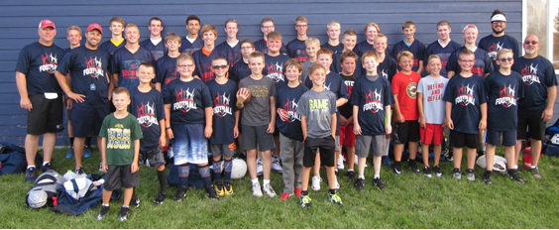
Future Falcon Football Camp
Students Entering 4th-8th Grades
July 13-15th : 6-8:00 PM Cost: $60.00/Per Player
Guest Speakers & Coaches: Former NDSU Players
Name:_________________________________________________________________
Grade Entering: _____________ Age: ____________ Phone: _______________________
Address: _______________________________________________________________
Any Medical Concerns: _____________________________________________________
T-Shirt Size: Youth – S M L XL Adult S M L XL
{t-shirt is included if registered by June 26th, 2020}
**No Refunds will be issued after July 1
Parent – Please read and sign below.
I hereby consent to have my child participate in the Future Falcon Football Camp. I understand that there are risks involved in participation in this camp’s activities. I certify that my child is medically fit and able to participate in the activities at camp. I authorize the camp staff to act in their best judgements in an emergency that requires medical attention for my child.
Parent: _______________________________________________________________ Date: _______________________
Send Registration with entry fee by July 1 to:
Park Christian Football 300 17th St. N. Moorhead, MN 56560

